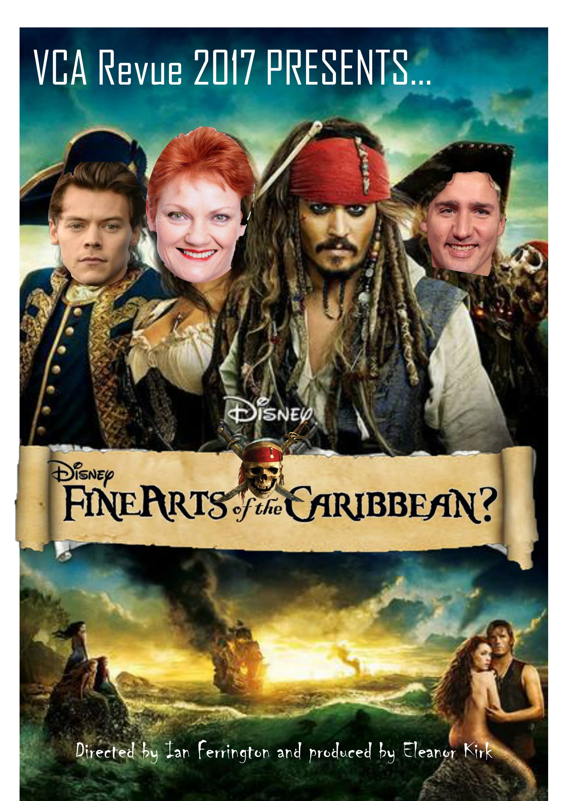
CAST
Alex Donnelly
Andy Jack Song
Aquilla Sorensen
Brooke Rayner
Chris King
Edward McCullough
Eleanor Kirk
Ian Ferrington
Karl Richmond
Lachie Clarke
Lauren Hunter
Nic Davey Greene
Phoebe Heath
MUSIC
Imogen Cygler (piano)
Alexandra C. Roper (drums)
Noah Hutchinson (bass)
WRITERS
Alex Donnelly
Andy Jack Song
Eleanor Kirk
Ian Ferrington
Lachie Clarke
Millie Holten
Nic Davey Greene
Phoebe Heath
Samuel Pratt-White
Sebastian Klarica
CREW
Alec Steedman
Lauren Hunter
Louis Stockfeld
Michael Norris
Nicholas Lam
Samuel Pratt-White
Sarah Fitzgerald
Sebastian Klarica
Sophie Gibson

ACT ONE
‘At the Start of the Show’ written by Ian Ferrington and arranged by Imogen Cygler
‘Pirate Insults’ written by Ian Ferrington
‘Joke Doctor’ written by Sebastian Klarica and Millie Holten
‘Actuary Audition’ written by Ian Ferrington and Nic Davey Greene
‘21st Eulogy’ written by Phoebe Heath
‘Exchange Student’ written by Sebastian Klarica
‘Sham-Meh’ written by Alex Donnelly
‘The Adopter’ written by Eleanor Kirk
‘Welcome to the VCA’ written and arranged by Andy Jack Song
‘Arts Student’ written by Sebastian Klarica
‘EFTPOS Minimum’ written by Eleanor Kirk
‘Backwards Bullies’ written by Lachie Clarke
‘Security Staff’ written by Ian Ferrington
‘Harassment Hotline’ written by Ian Ferrington
‘Mum in the Audience #1’ written by Lachie Clarke
‘Singlet Surgeon’ written by Ian Ferrington
‘Cards Against Democracy’ written by Eleanor Kirk
‘Drunk Magician’ written by Lachie Clarke
‘Ain’t No Mountain High Enough’ written by Ian Ferrington and arranged by Imogen Cygler

ACT TWO
‘Don’t Put Me Down’ written by Alex Donnelly and arranged by Imogen Cygler
‘Peg Leg’ written by Ian Ferrington
‘Pitching Existing Films’ written by Sebastian Klarica and Eleanor Kirk
‘Mum in the Audience #2’ written by Lachie Clarke
‘Grandma’s Dead’ written by Phoebe Heath
‘Genesis’ written by Ian Ferrington
‘Justin Trudeau’ written by Eleanor Kirk
‘Cult Meeting’ written by Lachie Clarke
‘STI Pets’ written by Sam Pratt-White
‘Date With A Buzzfeed Worker’ written by Eleanor Kirk
‘Ms Doctor Who’ written by Ian Ferrington
‘Locker Room Talk’ written by Sebastian Klarica and Millie Holten
‘War With France’ written by Ian Ferrington
‘Pitching Pirates of the Caribbean’ written by Ian Ferrington
‘Season These Doves’ written by Nic Davey Greene and Ian Ferrington and arranged by Imogen Cygler

Special thanks to our talented musicians, dedicated crew, and Union House Theatre for their enduring patience and expertise!

